KV4004 – AI Fundamentals

Workshop 9

November 2024

Exercise 1

Analyse text with Language Studio

1.1 Introduction

In this exercise you will explore the capabilities of Azure AI Language by analysing some example hotel reviews. You’ll use Language Studio to understand whether the reviews are mostly positive or negative.

Natural Language Processing (NLP) is a branch of AI that deals with written and spoken language. You can use NLP to build solutions that extract semantic meaning from text or speech, or that formulate meaningful responses in natural language.

For example, suppose the fictitious travel agent Margie’s Travel encourages customers to submit reviews for hotel stays. You could use the Language service to identify key phrases, determine which reviews are positive and which are negative, or analyse the review text for mentions of known entities such as locations or people.

Azure AI Language Service includes text analysis and NLP capabilities. These include the identification of key phrases in text, and the classification of text based on sentiment.

1. Sign in to Azure VM via <https://msle.learnondemand.net> using your Microsoft VM account credentials.

1. Click ‘My Training’, and choose ‘**AI Fundamentals 1 KV4004 (AI-900)**’ class

1. Launch the first VM ‘Analyze test with Language studio”

1.2 Create a Language resource

 For the exercise below, we will use a **Language** resource. If you haven’t already done so, create a **Language** resource in your Azure subscription.

1. In browser tab, open the Azure portal at [https://portal.azure.com](https://portal.azure.com/?azure-portal=true), signing in with the Microsoft account associated with the user name and pwd provided by VM.
2. Click the **＋Create a resource** button and search for ***Language service***. Select **create** a **Language service** plan. You will be taken to a page to **Select additional features**. Keep the default selection and click **Continue to create your resource**.

1. On the page **Create Language**, configure it with the following settings: (see Figure 1.1)
   1. **Subscription**: *Your Azure subscription*.
   2. **Resource group**: *Select or create a resource group with a unique name*.
   3. **Region**: UK South.
   4. **Name**: *yourID-language-service*
   5. **Pricing tier**: *Free F0 or S if Free yourID-language-service F0 is not available*
   6. **By checking this box I acknowledge that I have read and understood all the terms below**: *Selected*.
2. Select **Review + create** then **Create** and wait for deployment to complete.

Create a language service.

1.3 Configure your resource in Azure AI Language Studio

1. In another browser tab, open [Language Studio](https://language.cognitive.azure.com/?azure-portal=true) (https://language.cognitive.azure.com) and sign in.
2. When prompted with **Select an Azure resource**, make the following configurations: (Figure 1.2)
   1. **Azure directory**: provided by VM
   2. **Azure subscription**: provided by VM
   3. **Resource type**: Language
   4. **Resource name**: select the Language service resource you just created.
3. Then select **Done**.

Configure your resource

**Note**: If you are **not** prompted to choose a language resource, it may be because you have multiple Language resources in your subscription; in which case:

1. On the bar at the top if the page, select **Settings (⚙)**.
2. On the **Settings** page, view the **Resources** tab.
3. Select the resource you just created, and select **Switch resource**. Ensure Managed identity is **Enabled**.
4. At the top of the page, select **Language Studio** to return to the Language Studio home page.
5. Details can be found in Figure 1.3

[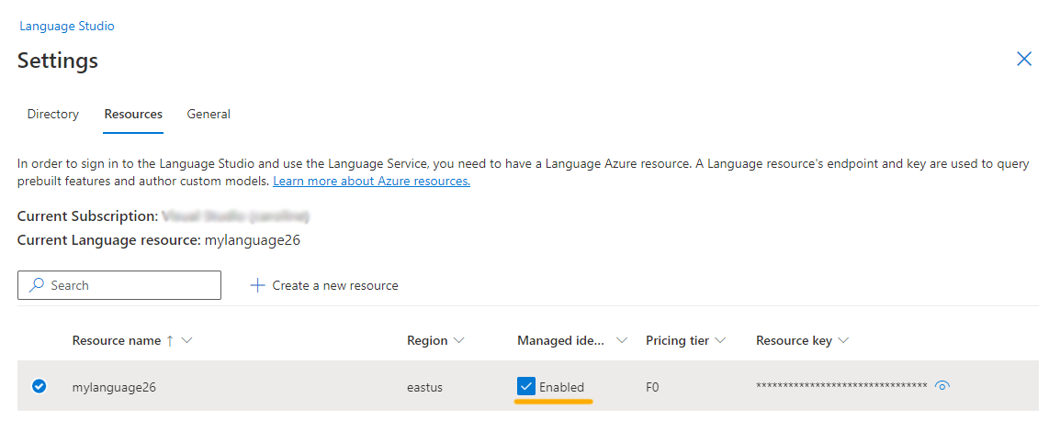](https://microsoftlearning.github.io/mslearn-ai-fundamentals/Instructions/Labs/media/analyze-text-language-service/language-resource-enabled.png)

1.4 Analyse reviews in Language Studio

1. In a web browser, navigate to [Language Studio](https://language.cognitive.azure.com/?azure-portal=true).
2. On the **Welcome to Language Studio** landing page, select the **Classify text** tab, then select the **Analyze sentiment and mine opinions** tile. (figure 1.4)

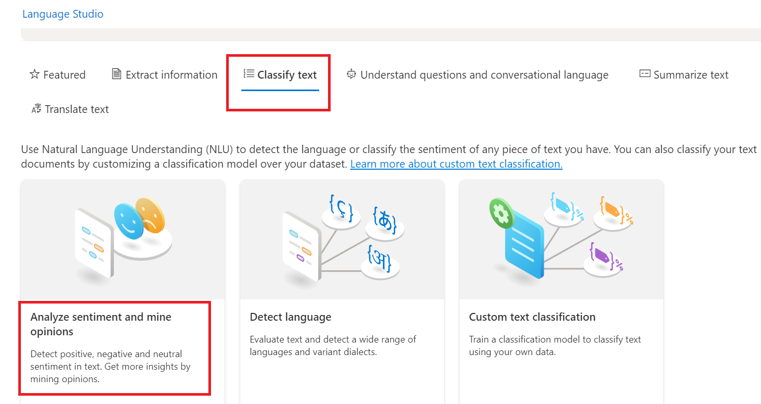

1. Under **Select text language**, select **English**.
2. Under **Select your Azure resource**, select your resource ( my resource is ‘ws8-kv4004’, see Figure as follows)

Figure 1.5

1. Under **Enter your own text**, upload a file, or use one of our sample texts, copy and paste the following review:

Tired hotel with poor service

The Royal Hotel, London, United Kingdom

5/6/2018

This is an old hotel (has been around since 1950's) and the room furnishings are average - becoming a bit old now and require changing. The internet didn't work and had to come to one of their office rooms to check in for my flight home. The website says it's close to the British Museum, but it's too far to walk.

1. Check the box to acknowledge that the demo will incur usage and may incur costs, and then select **Run**.

1. Review the output. Notice that the *document* is analysed for sentiment, as well as each ***sentence***. Select **Sentence 1** to show the sentiment analysis for that sentence. (See Figure 1.6)

**Notice** that there is an overall sentiment followed by scores next to three categories, positive score, neutral score, negative score. In each of the categories, a score between 0 and 1 is provided. These confidence scores indicate how likely the provided text is a particular sentiment.

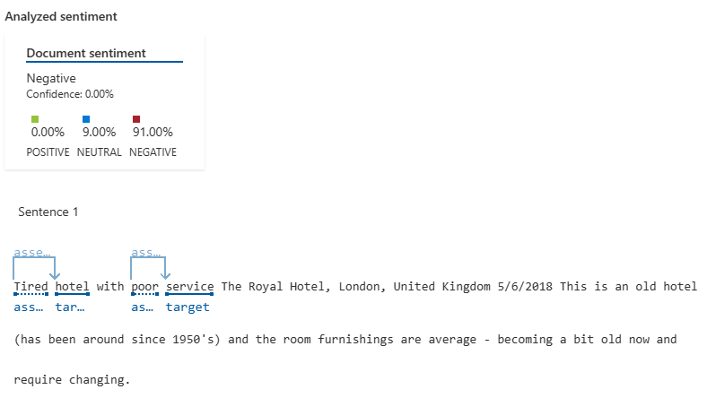

1. Scroll up to select **Clear text box**, and copy and paste the following review:

Good Hotel and staff

The Royal Hotel, London, UK

3/2/2018

Clean rooms, good service, great location near Buckingham Palace and Westminster Abbey, and so on. We thoroughly enjoyed our stay. The courtyard is very peaceful and we went to a restaurant which is part of the same group and is Indian ( West coast so plenty of fish) with a Michelin Star. We had the taster menu which was fabulous. The rooms were very well appointed with a kitchen, lounge, bedroom and enormous bathroom. Thoroughly recommended.district with lots of good places to eat, within walking distance to Presidio. May be good hotel for young stay-up-late adults on a budget

1. Select **Run**. Review the output and review the sentiment and confidence level.

1. Select **Clear text** box again, and copy and paste the following review:

Very noisy and rooms are tiny The Lombard Hotel, San Francisco, USA 9/5/2018 Hotel is located on Lombard street which is a very busy SIX lane street directly off the Golden Gate Bridge. Traffic from early morning until late at night especially on weekends. Noise would not be so bad if rooms were better insulated but they are not. Had to put cotton balls in my ears to be able to sleep–was too tired to enjoy the city the next day. Rooms are TINY. I picked the room because it had two queen size beds–but the room barely had space to fit them. With family of four in the room it was tight. With all that said, rooms are clean and they’ve made an effort to update them. The hotel is in Marina district with lots of good places to eat, within walking distance to Presidio. May be good hotel for young stay-up-late adults on a budget

1. Select **Run** and review the sentiment together with the confidence level. Have a look at the text and compare the text to the sentiment analysis that the service returned.

Exercise 2

Use Conversational Language Understanding with Language Studio

2.1 Introduction

Increasingly, we expect computers to be able to use AI to understand natural language commands, either spoken or typed. For example, you might want a home automation system to control devices in your home by using voice commands such as “switch on the light” or “put the fan on.” AI-powered devices can understand these commands and take appropriate action.

In this exercise, you will use Language Studio to create and test a project that sends instructions to devices such as lights or fans. You’ll use the capabilities of the Conversational Language Understanding service to configure your project.

2.2 Create a Conversational Language Understanding App

1. Go back to the language studio. At the top of the portal, in the **Create new** menu, select **Conversational language understanding**.

1. In the **Create a project** dialog box, on the **Enter basic information** page, enter the following details and select **Next**:
   * **Name**: Create a unique name
   * **Utterances primary language**: English
   * **Enable multiple languages in project**: Do not select
   * **Description**: Simple home automation

**Tip**: Make a note of your project name, you will use it later.

2.3 Create intents, utterances, and entities

An intent is an action you want to perform - for example, you might want to switch on a light, or turn off a fan. In this case, you’ll define two intents: one to switch on a device, and another to switch off a device. For each intent, you’ll specify sample utterances that indicate the kind of language used to indicate the intent.

1. In the **Schema definition** pane, ensure that **Intents** is selected then select **Add**, and add an intent with the name switch_on (in lower-case) and select **Add intent**. (figure 2.3)

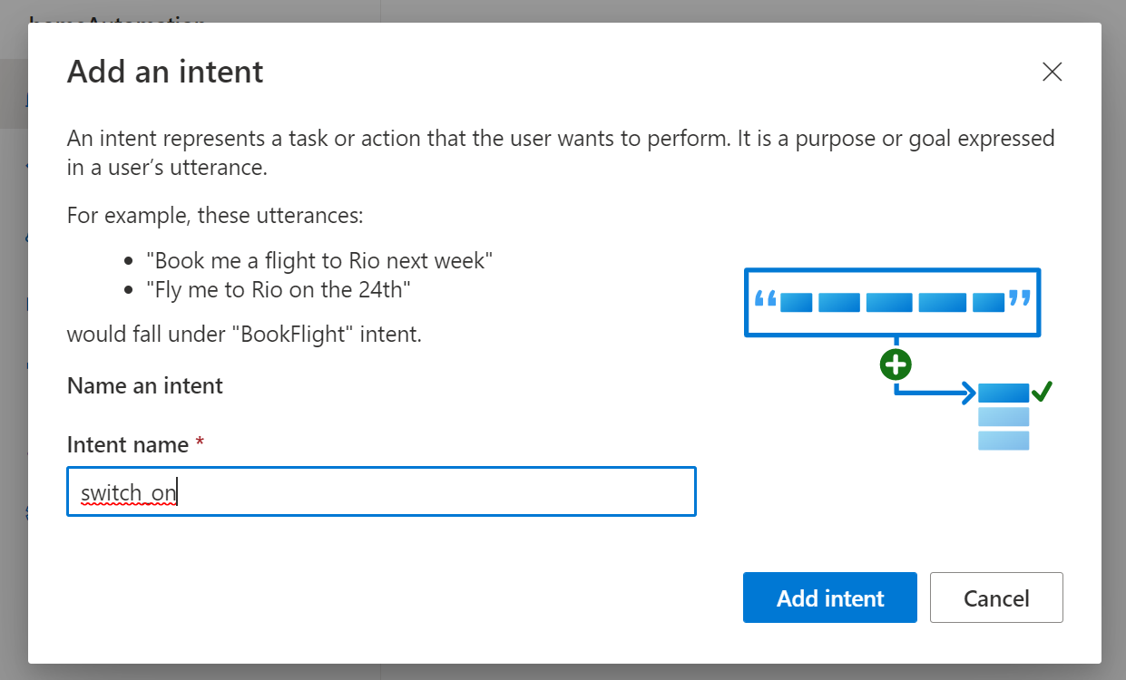

Figure 2.3

1. Select the **switch_on** intent. It will take you to the **Data labeling** page. In the **Intent** drop down, select **switch_on**. Next to the **switch_on** intent, type the utterance turn the light on and press **Enter** to submit this utterance to the list. (Figure 2.4)

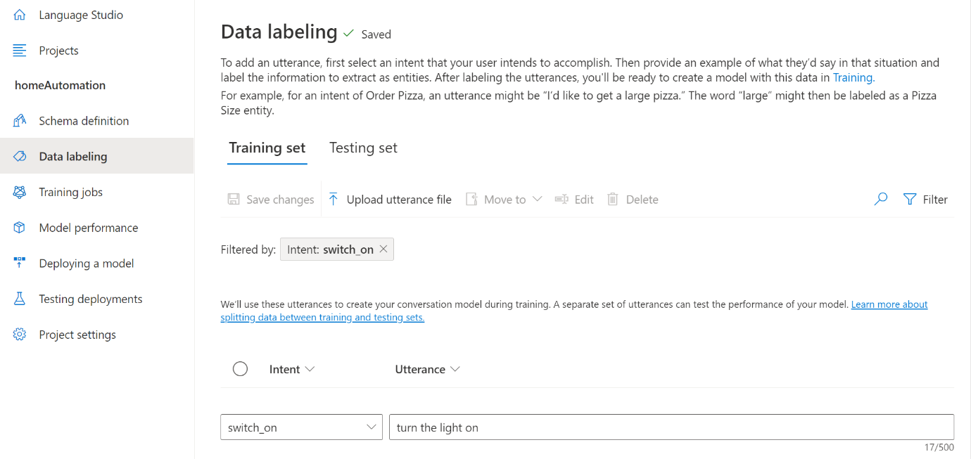

Figure 2.4

1. The language service needs at least five different utterance examples for each intent to sufficiently train the language model. Add five more utterance examples for the **switch_on** intent:

* switch on the fan
* put the fan on
* put the light on
* switch on the light
* turn the fan on

1. On the **Labeling entities for training** pane on the right-hand side of the screen, select **Labels**, then select **Add entity**. Type device (in lower-case), select **List** and select **Add entity**, see Figure 2.6.

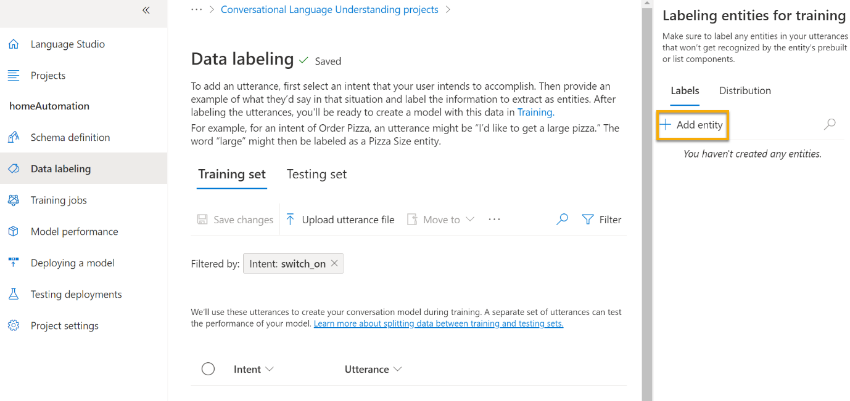

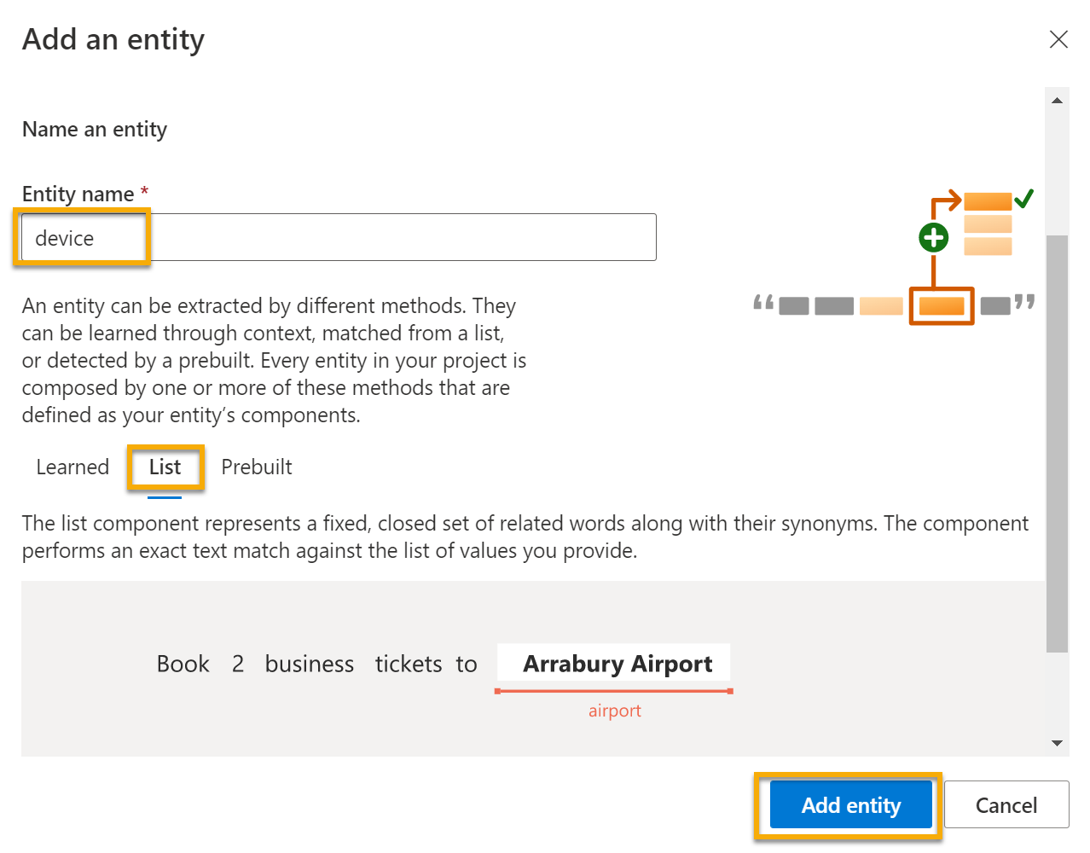

1. In the **turn the fan on** utterance, highlight the word “fan”. Then in the list that appears, in the Search for an entity box select **device**. (Figure 2.6)

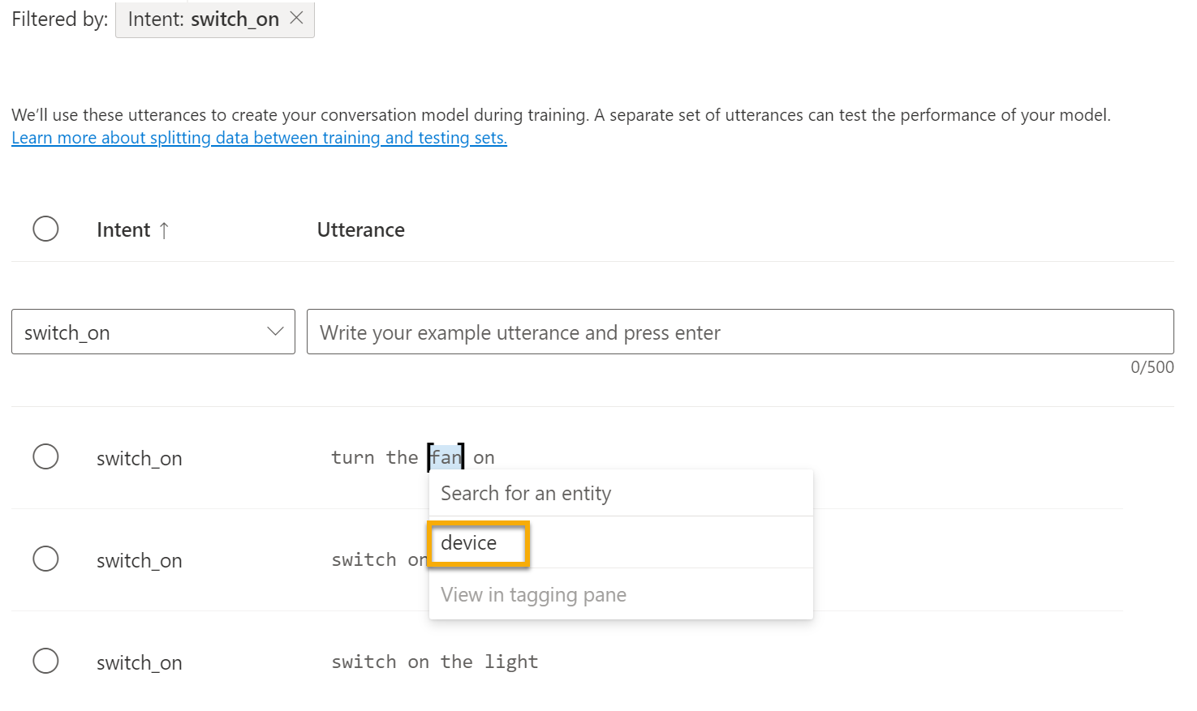

1. Do the same for all the utterances. Label the rest of the **fan** or **light** utterances with the **device** entity (table 1). When you’re finished, verify that you have the following utterances and make sure to select **Save changes** : (figure 2.7 & figure 2.8)

|  |  |  |
| --- | --- | --- |
| **intent** | **utterance** | **entity** |
| switch_on | Put on the fan | Device - select fan |
| switch_on | Put on the light | Device - select light |
| switch_on | Switch on the light | Device - select light |
| switch_on | Turn the fan on | Device - select fan |
| switch_on | Switch on the fan | Device - select fan |
| switch_on | Turn the light on | Device - select light |

Table 1

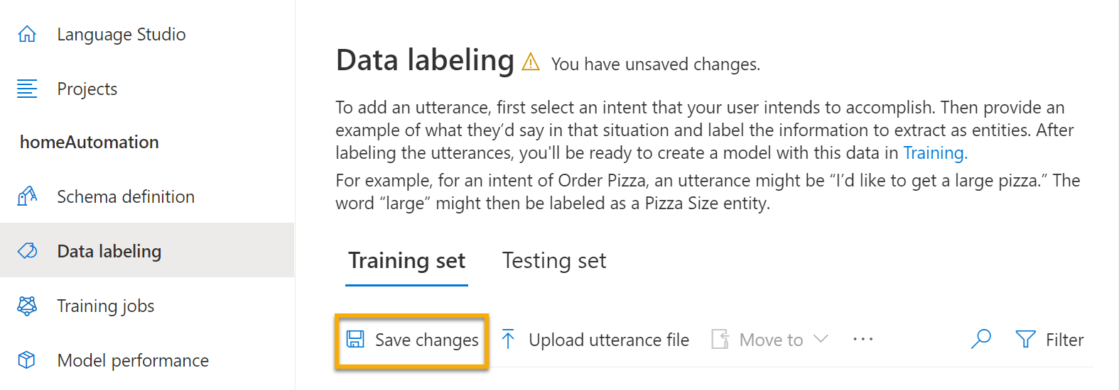

1. In the pane on the left, select **Schema definition** and verify that your **switch_on** intent is listed. Then select **Add** and add a new intent with the name switch_off (in lower-case). (Figure 2.9)

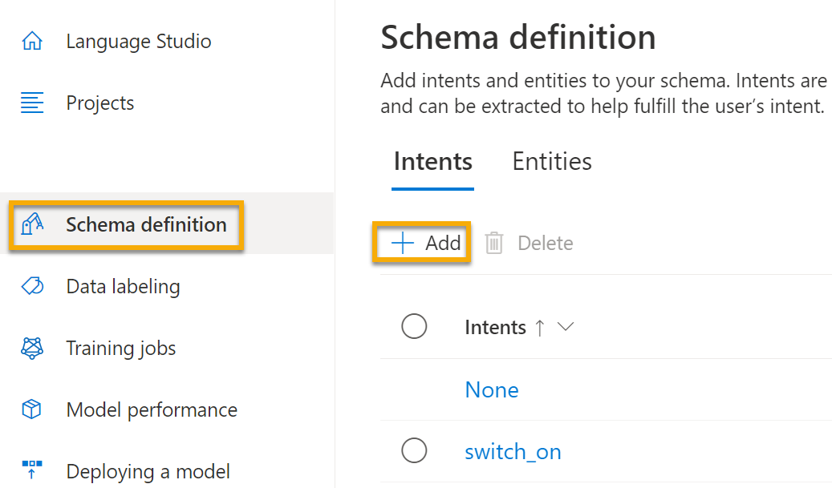

1. Select the **switch_off** intent. It will take you to the **Data labeling** page. In the **Intent** drop down, select **switch_off**. Next to the **switch_off** intent, add the utterance turn the light off.

Add five more utterance examples to the **switch_off** intent.

* switch off the fan
* put the fan off
* put the light off
* turn off the light
* switch the fan off

1. Label the words **light** or **fan** with the **device** entity (table 2). When you’re finished, verify that you have the following utterances and make sure to select **Save changes**:

|  |  |  |
| --- | --- | --- |
| **intent** | **utterance** | **entity** |
| switch_off | Put the fan off | Device - select fan |
| switch_off | Put the light off | Device - select light |
| switch_off | Turn off the light | Device - select light |
| switch_off | Switch the fan off | Device - select fan |
| switch_off | Switch off the fan | Device - select fan |
| switch_off | Turn the light off | Device - select light |

Table 2

2.4 Train the model

1. On the left hand side of Language Studio, select **Training jobs**, then select **Start a training job**. Use the following settings:
   * **Train a new model**: Selected and choose a model name (here I use workshop8Model)
   * **Training mode**: Standard training (free)
   * **Data Splitting**: select Automatically split the testing set from the training data, keep default percentages
   * Select **Train** at the bottom of the page.

1. Wait for training to complete.

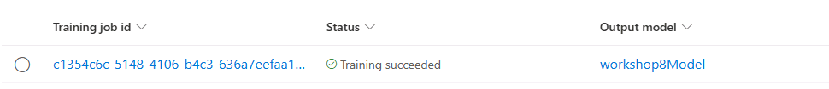

2.5 Deploy and test the model

To use your trained model in a client application, you must deploy it as an endpoint to which the client applications can send new utterances; from which intents and entities will be predicted.

1. On the left-hand side of Language Studio, select **Deploying a model**.
2. Select **Add deployment**. Use these settings:
   * **Create or select an existing deployment name**: Select create a new deployment name. Add a unique name. (here I use workshop8Deploy)
   * **Assign trained model to your deployment name**: Select the name of the trained model. ( my trained model is called workshop8Model)
   * Select **Deploy**

1. When the model is deployed, select **Testing deployments** on the left-hand side of the page, and then select your deployed model under **Deployment name**.
2. Enter the following text, and then select **Run the test**:

switch the light on

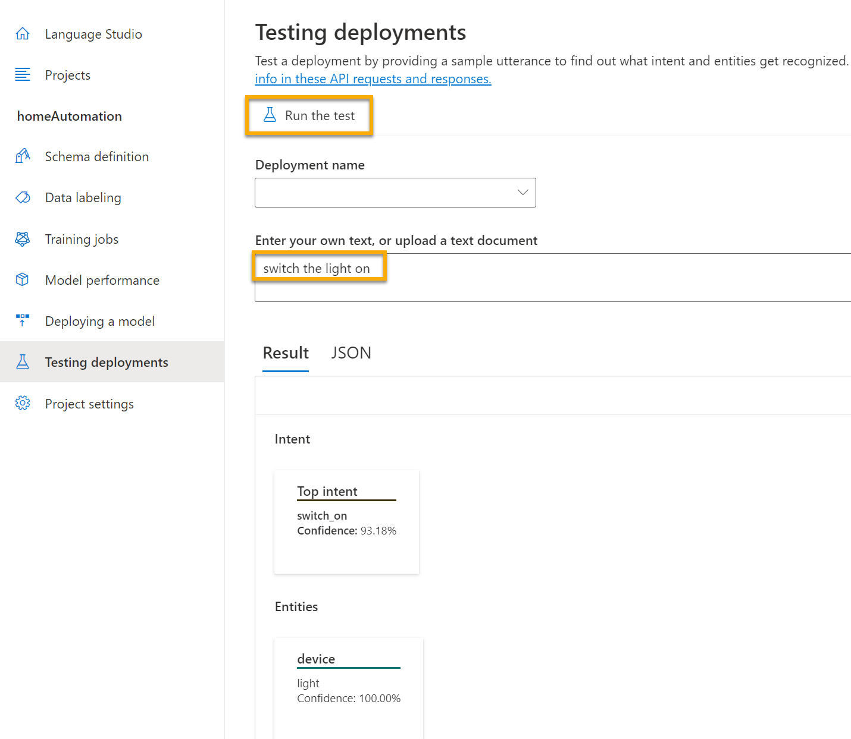.

1. Review the result that is returned, noting that it includes the predicted intent (which should be **switch_on**) and the predicted entity (**device**) with confidence scores that indicates the probability the model calculated for the predicted intent and entity . The JSON tab shows the comparative confidence for each potential intent (the one with the highest confidence score is the predicted intent)

1. Clear the text box and test the model with the following utterances under Enter your own text, or upload a text document:
   * turn off the fan
   * put the light on
   * put the fan off

You have now successfully configured a conversational language project, and defined entities, intents, and utterances. You have seen how to train and deploy a model in the Language Studio. And you have tried it out with both utterances you defined, and some that you did not explicitly define but the model was able to determine.

**NOTE**: Conversational language understanding provides the intelligence to interpret the intention of the input; it doesn’t perform any actions such as turning on the light or the fan. A developer would need to build an application that uses the Conversational Language Understanding model to determine the user’s intent, and then automate the appropriate action.